Removing Intune Comp Portal App on an iOS Device

Introduction:
This document describes how to remove your current management profile before installing your new management portal on your company-provided iOS device, such as an iPhone.
Before you proceed with these instructions, make sure you know your iOS device’s passcode. You will need your passcode to successfully follow these instructions.
Only follow these instructions if you currently have the Comp Portal app installed on your iOS device. When you follow steps 1 and 2 below, if you do not see a management profile listed, do not proceed.
Step: | Action:
1 | Go to the Settings app on your device.  
2 | Tap on “General” and scroll down to “VPN & Device Management.” Then, tap on “Management Profile.”  A  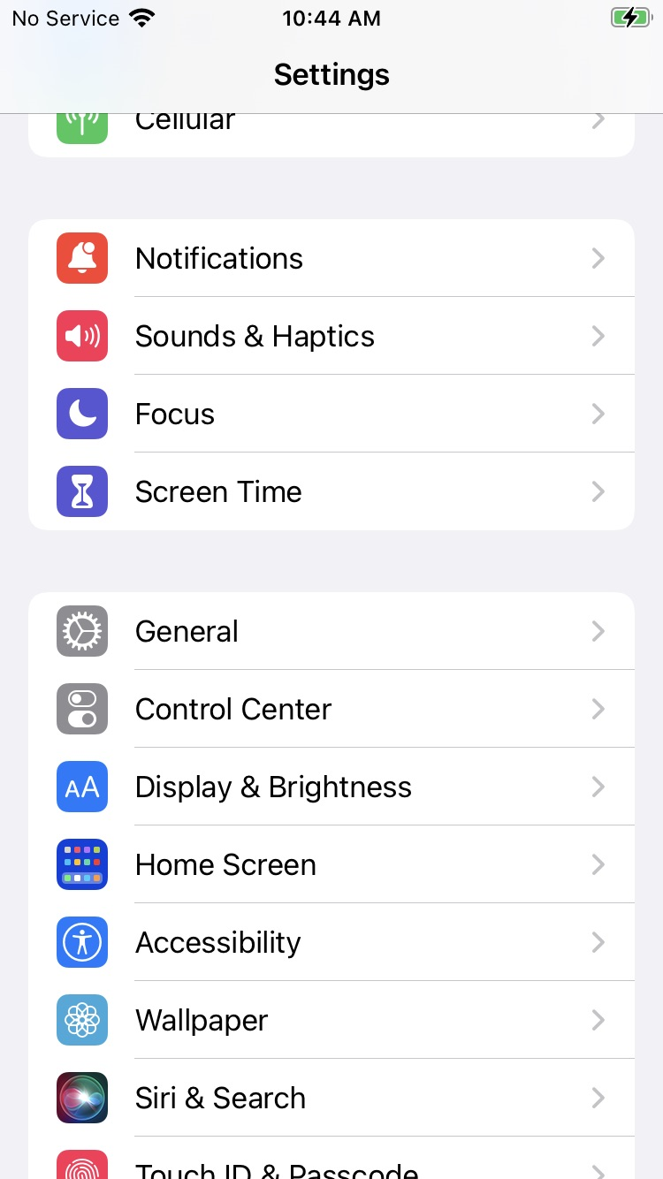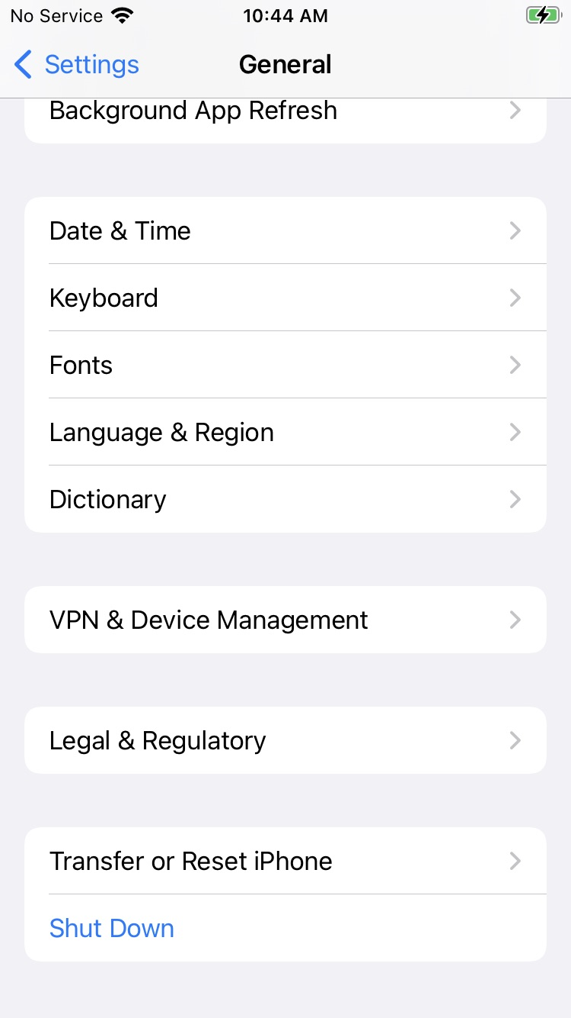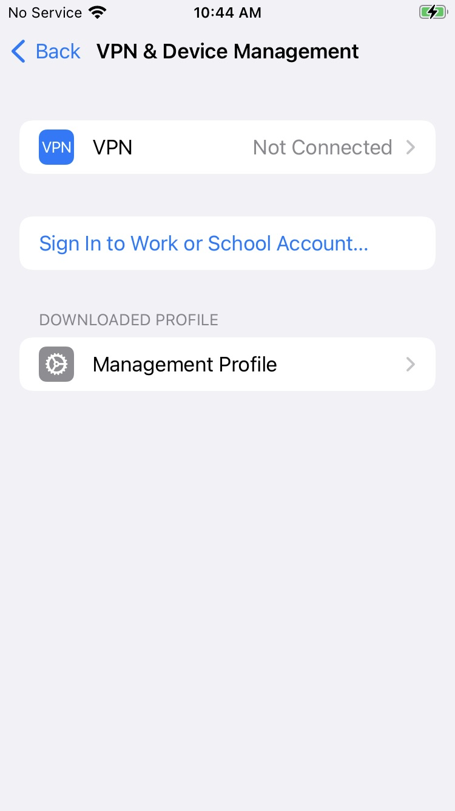
3 | Tap on “Remove Management.”  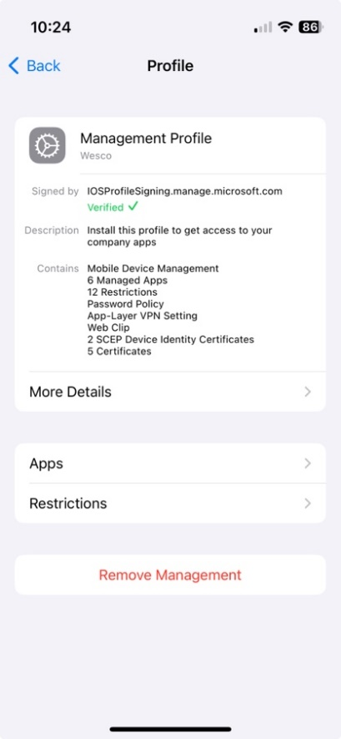
4 | You will be prompted to enter your iPhone passcode (the same passcode you use to unlock your mobile device).
5 | Proceed to enroll your iOS device in the new management profile by following the instructions located in the Digital Evolution SharePoint site’s Active Directory Tenant Migration resources folder.

Comp Portal App FAQs
Q. Who do I contact if I have issues following this guide?
A. Please contact the Global Service Desk at 770-663-2020.

